Drafting to Revising

Essay Composition Master Checklist

Introduction | - Identifies the work or body of work focused upon.  - Establishes line of inquiry that explicitly examines authorial choices and how they generate meaning, or incorporates contextual elements but approaches them from a literary or linguistic perspective.  - Thesis statement clearly indicates the relevant features of the work(s) and the interpretation you will argue and provide evidence for.
Body Paragraphs | - Each body paragraph begins with a topic sentence that establishes the interpretive claim elaborated in the paragraph and the aspect or component of the work(s) that you analyze to support it.  - Each paragraph provides textual evidence for a particular claim, including quotation(s), references to specific features of the work or specific repeated or related features across a body of work.  - Each paragraph ends with a transitional sentence that links the interpretive claim of that paragraph to the topic, claim, or focus of the next. (Or, a transitional phrase at the beginning of the next paragraph’s topic sentence provides the link.)
References / Textual Evidence | - Every quotation is embedded in a sentence that integrates or flows smoothly with the surrounding sentences. No isolated quotations.  - Every quotation from, paraphrase of, or direct reference to the work(s) includes a parenthetical citation before the period of the sentence.  - If writing about a graphic novel, TV show, advertisement, film, etc., then embed the relevant panels/texts/stills being analyzed within the body of the essay.  - Hyperlinks won’t work in examiners’ copies, so either include the linked work(s) in an appendix or provide clear and complete reference information to allow the examiner to access the material.  - Works Cited page with complete citations for all work(s) referenced or written about.
Conclusion | - Proposes a significant, persuasive re-/interpretation of the work(s) as a whole.  - States how that significant interpretation emerges as the culminating implication of the sustained analysis you developed, completing your essay’s line of inquiry.
Sentence-level | - Purposeful and accurate transitional phrases between sentences and paragraphs.  - Strong verbs  - Read essay aloud to check for errors or awkward moments in grammar and sentence structure.
Format | - Title Page [Double-check with your teacher for final formatting guidance]  English A: Language and Literature  Literary/Non Literary Body of Work: [Text Type] by [Author]  Higher Level Essay  Line of Inquiry: [“...?”]  Word Count: [####]

Lang & Lit Academic Essay Conventions
(adapted from Harvard Writing Center’s Brief Guide to Writing the English Paper, p. 6)

- Avoid plot summary. An essay that recounts what happened in a narrative work--or that analyzes selected scenes in the same order they occur in the work–is letting the novel’s author rather than the essay’s author structure the paper’s argument. Instead, you can focus on selected scenes, briefly identifying them before analyzing significant details. Resist shadowing the narrative’s/work’s chronology in your own paper. One rule of thumb is to begin with the most obvious piece of evidence and move progressively to the least obvious piece of evidence.

- Avoid basing your argument on opinion. Sometimes works provoke personal feelings and opinions in a reader/audience. When this happens, the reader should try to suspend those personal feelings and opinions as they close read, paying attention instead to structures and features in the text. Textual evidence and not personal conviction should be the basis of your thesis and argument.
These works don’t tell you what to feel or think; they show or provoke feelings and lines of thought. Look for the authorial choice / textual feature, technique, device, language, form, etc., that provokes or models the thoughts and feelings as effects on the reader.

- Distinguish between “speakers” and authors. Because English papers make claims about texts rather than about authors, poems and narratives have a “speaker” or “narrator” who should not be confused with the author. David Copperfield, while he has autobiographical features, is not Charles Dickens himself.

- Write in the present tense. Because English papers approach literary works as linguistic artifacts rather than as historical documents, they discuss characters and events in the present tense rather than the past tense. For example, one might write: “In The Stranger, Mersault expresses disdain for the conventional concerns of those around him.”

- Use MLA style citations. Because English papers quote frequently, often from the same text, they cite page numbers parenthetically. For example: In The Stranger, Mersault expresses disdain for conventional social expectations and instead ultimately opens himself “to the gentle indifference of the world” (122).

Transitional Words and Phrases

Transitional language is important for clearly presenting complex  ideas by ensuring readers understand the logical connections and  reasoning that join each part of the composition in a meaningful sequence.  When papers lack transitional words and phrases, they start to read  like “choppy” lists of statements, or a mass of stand-alone paragraphs  about a topic. They might present a lot of different thoughts or  information, but they don’t show how these fit together to advance a  new, richer view of the topic (as proposed in thesis statements).  Improve clarity and cohesion—and avoid the dreaded “lack of flow”—  by using transitional words and phrases to create powerful links  between your ideas and help readers understand the paper’s logic.  Transitional language guides readers through complex ideas and  arguments by marking where you’re going and how you’re getting  there.  *In addition to improving clarity and cohesion, being purposeful and selective about you transition phrases in and between paragraphs will improve the ACCURACY, INCISIVENESS, and LOGICAL COHERENCE of your interpretive argument and analysis. One of IB examiners’ main criticisms of the HL essays has been the lack of accurate language and coherence of interpretive argument. | Use transitional words and phrases at the sentence- and paragraph-levels in your own writing to…  Build on the preceding text  Addition (of info or emphasis): also, and, in fact, indeed, moreover, in  addition, furthermore, besides X, both X and Y, above all, more/most  importantly  Example: such as, for instance, in particular, notably, consider, specifically,  for example, as an illustration  Clarification: actually, in other words, by extension, ultimately, in short, that  is (to say), namely, more precisely, to put it another way  Similarity: similarly, in like manner, likewise, equally, in the same way, by  the same token  Reference: regarding, considering, the fact that, as for, on the subject of  Contrast or challenge the preceding text  Contrast: but, however, though, equally, by way of contrast, while, on the  other hand, (and) yet, whereas, in contrast, (when) in fact, conversely,  despite, while, nonetheless  Concession: admittedly, granted, of course, although (it is true),  notwithstanding, even so, on the other hand  Dismissal: regardless, whatever the case, all the same  Make a causal connection  Causation/consequence: accordingly, as a result, consequently, thus,  hence, therefore, since, because, for this reason, as a result  Condition: (even) if, (only) when, on the condition that, in the case that,  provided that, in the event, unless, given that, inasmuch as, insofar as,  otherwise, if so  Indicate ordering  Sequence: first, second, third..., to begin, at first, initially, first of all,  subsequently, previously, after, before, next, then, eventually, at last,  finally, lastly, to conclude, as a final point  Retrospection: to return to, to resume, as previously stated/mentioned,  overall, in summary, briefly, given these points, as has been noted, in  sum, altogether, to summarize

Using Strong Verbs in Evidence and Analysis - Quotations
(Source: Gerald Graff and Cathy Birkenstein, They Say/I Say: The Moves that Matter in Academic Writing, 5th ed., W.W. Norton & Co., 2021.)

The following formula and templates refer to embedding quotations from secondary sources, but they are easily adapted to writing about literary works. The two groups of signal words below are excellent for incorporating strong verbs in your sentences!

Embedding quotations in sentences
When quoting a source in your writing, the quotation becomes part of the paragraph in which it
appears. Since paragraphs are made up of sentences, you’ll need to embed the quotation itself in a
sentence of your own making.
Embedding quotations places them in the context of your own writing. To embed a quotation in the
sentence, identify the source and introduce the quotation with a signal word.

Strong Verbs: Common signal words

says (if quoting speech/dialogue) emphasizes claims acknowledges
writes suggests contends reports
states observes argues explains
remarks continues agrees/disagrees urges

Framing quotations in your writing
Frame every quotation to clearly present its relevance and meaning for readers by applying this two-part formula called a “quotation sandwich” (51). As if sandwiching ingredients between two slices of bread, for a “quotation sandwich” you insert the quotation between the introductory statement that introduces and embeds the quotation in the sentence, and a follow-up sentence that explains why the quotation is important and what you understand it to mean.

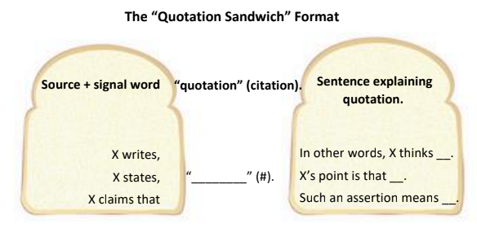

Pro Tip for using the “quotation sandwich” format in your writing

Notice that signal words appear in both sets of templates above. This is because signal words are
descriptive verbs that introduce quotations as well as introducing summaries, explanations, and
redescriptions of what was stated.

You can enhance the clarity, impact, and sophistication of your writing when explaining quotations by
selecting more specific descriptive verbs that appropriately signal what you take the quoted author’s
meaning or purpose to be.

Try this technique when you quote sources in your writing:
- When introducing quotations, focus on presenting information about the source (such as title, topic, genre, author, author’s credentials, etc.) and use a common or neutral signal word, such as the common signal words listed on the first page.
- Then, choose a more specifically expressive, emotionally-charged, and/or value-laden, signal word to introduce and reinforce your explanation of the quotation. The second group of strong verbs below provides a sampling of these more specific and expressive signal words.

Strong Verbs: Specific and Expressive Signal Words
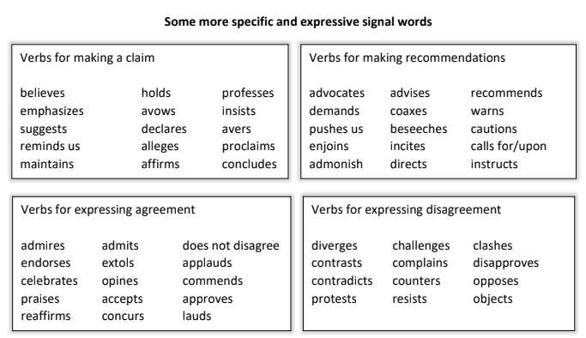

Templates for crafting a “quotation sandwich”: introducing and explaining

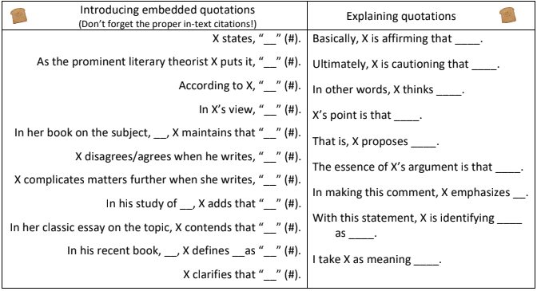

Writing Exercises for Drafting and Revision

- Make a couple more templates for introducing and embedding quotations using the lists of signal words and the formula:
Identify source X + signal word/phrase + “____” (#).

- Make a couple more templates for explaining or summarizing quotations using the lists of more specific and expressive signal words.
For example: By challenging ____, X advances her own view that _____.
In maintaining ______, X confuses _____ and _____.

- Apply the “quotation sandwich” model to the quotations and direct references in your HL essay.

Practice:
1. introducing the source and using signal words to embed the quotation in a sentence with proper punctuation and citation, and
2. following-up with a sentence that explains or summarizes the importance of the quotation and tells readers what you take the meaning to be

Subject Reports & IB’s 10 Tips

May 2022 Subject Report

Nov 2021 Subject Report

IB’s 10 Tips for the HL Essay

IB Assessment Criteria

Criterion A: Knowledge, understanding, and interpretation / 5 marks
- How well does the candidate demonstrate knowledge and understanding of the work or body of work chosen?
- To what extent does the candidate make use of knowledge and understanding of the work or body of work to draw conclusions in relation to the chosen line of inquiry?
- How well are ideas supported by references to the work or body of work in relation to the chosen line of inquiry?
Criterion B: Analysis and evaluation / 5 marks
- To what extent does the candidate analyse and evaluate how the choices of language, technique and style, and broader authorial choices shape meaning in relation to the chosen line of inquiry?

“It is not enough to simply identify a specific feature without discussing the effects created.” - Subject Report Nov 2021
Criterion C: Focus, organization, and development / 5 marks
- How well organized, focused and developed is the presentation of ideas in the essay?
- How well are examples integrated into the essay?

- Reverse outline to refine your essay structure and organization
Criterion D: Language / 5 marks
- How clear, varied and accurate is the language?
- How appropriate is the choice of register and style? (“Register” refers, in this context, to the candidate’s use of elements such as vocabulary, tone, sentence structure and terminology appropriate to the HL essay).

- Read paper aloud to catch mistakes and awkward phrasing.

